**SOURCE 1 –**

<http://www.skwirk.com/p-c_s-14%20_u-173_t-471_c-1705/timeline-of-ancient-china/nsw/history/ancient-societies---china/ancient-china:-part-i#quiz>

**Name of website – Timeline of Ancient China**

**Date: 7/6/2015**

**----------------------------------------------------------------------------------------------------------------------------**

**Xia** **Dynasty** (approx 2000 BC - 1600 BC)

For many years experts believed that the Xia Dynasty was a legend. Excavations in 1959, however, found what is thought to have been the site of Yanshi, the capital of the Xia dynasty. Carbon dating shows that people occupied the site from around 2100 BC and were the ancestors of the Shang people. The people of the Xia were agricultural people who used bronze tools and weapons and were governed by spiritual ruling families.

**Shang dynasty** (approx 1600 BC - 1027 BC)

The Shang dynasty is widely accepted as beginning the first known line of rulers. Cities started to grow during this time. The Shang is considered to have been the first real dynasty of China. Writing in China developed during the Shang dynasty.

**Zhou dynasty** (approx 1027 BC - 221 BC)

The Zhou were a warlike people from Wei river valley. Zhou rulers expanded the land of the Shang dynasty. The Zhou dynasty covered a long period of time and is split into Eastern and Western periods:

* Western Zhou 1027-771 BC
* Eastern Zhou 770-221 BC. The Eastern Zhou is further divided into:
  + Spring and Autumn period 770-476 BC
  + Warring States period 475 - 221 BC

**Qin dynasty** (221BC - 207 BC)

Shi Huangdi became ruler of the Qin state in 246 BC. The Qin became the most powerful of the warring states and in 221 BC Shi Huangdi united the states. Shi Huangdi became the first emperor of a unified China.

**Han dynasty** (206 BC - 220 AD)

* Western Han dynasty (206 BC - 24 AD)
* Eastern Han ( 25AD - 220 AD)

The Qin was a short-lived dynasty but it implemented many important reforms. The Han defeated Shi Huangdi's successor and continued the centralisation put in place by the Qin. One of the Han dynasty's main concerns was defending China from the Huns of Central Asia. The Silk Road was established during Han times.

**Three Kingdoms** (220 AD - 280 AD)

Following the fall of the Han dynasty, China fell into chaos again. Three kingdoms emerged from the disunity and each controlled their own land. The kingdoms were the Wei in northern China, the Shu in western China and the Wu in the east.

**Jin dynasty** (280 AD - 420 AD)

* **Western Jin** (280- 316)
* **Eastern Jin** ( 317 - 420)

**Southern and northern dynasties** (420 AD - 589 AD)

* Northern 386-581
* Southern 420 - 589

During this time, China was split into north and south and was ruled by separate dynasties.

**Sui** (589 AD - 617 AD)

**Tang Dynasty** (618- 907)

**Five dynasties and ten states** (907 - 979)

**Song Dynasty** (960 - 1127)

**SOURCE 2 –**

<https://msuweb.montclair.edu/~lebelp/Millennium.html>

**Name of website – The Dynasties of China**

**Date: 7/6/2015**

**[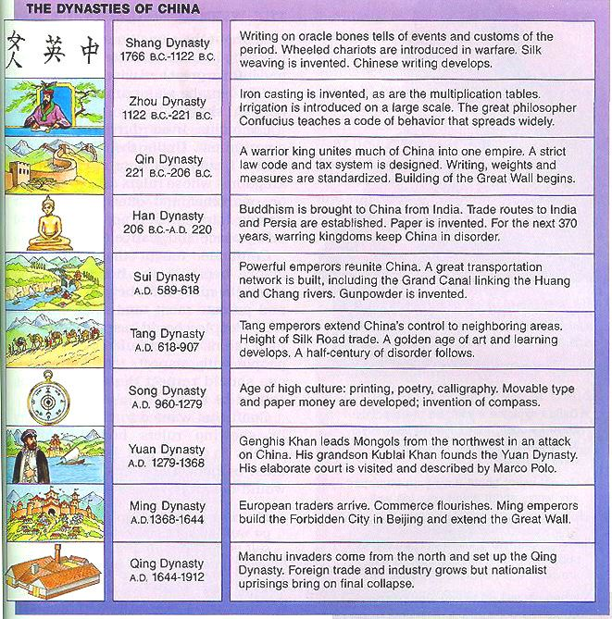](http://msuweb.montclair.edu/~lebelp/Millennium.html)**